3.1.1:

F = [1.75183168875261e-09, -1.86674315689630e-08, -8.52016381160499e-06;

-6.45671395631849e-08, -4.02137867037848e-10, 0.000495676907212069;

1.66353907424753e-05, -0.000476097927042134, -0.00205693230902430;]

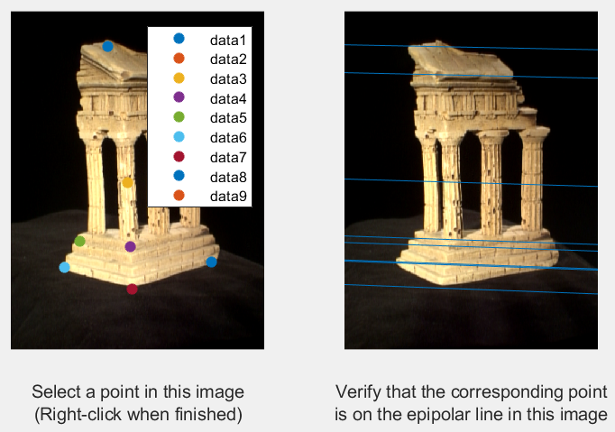

3.1.2:

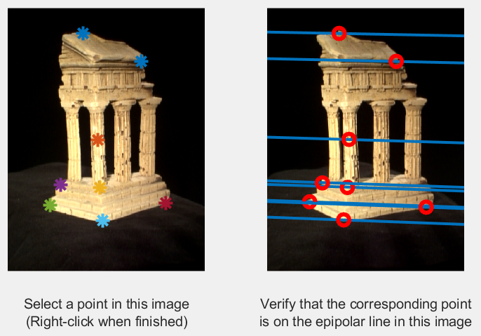

I used Euclidean distance for similarity metric. This matching algorithm might fail when pictures have repeated patterns, because repeated patterns have similar Euclidean distance. It also might fail when pictures have areas with no pattern but pure color, because points in these areas also have similar Euclidean distance.

3.1.3:

E = [0.00404956244132062, -0.0433080372767750, -0.0191554874996294;

-0.149794366553689, -0.000936326071206588, 0.726416434975663;

0.00186296855297823, -0.735240786278836, -0.000846576656319611;]

3.1.4:

camera2(E) will give fore candidate extrinsic matrices, I choose the extrinsic matrices with most positive Z, which has most points in front of images.

re-projection error using pts1: 0.5611

re-projection error using pts2: 0.5658

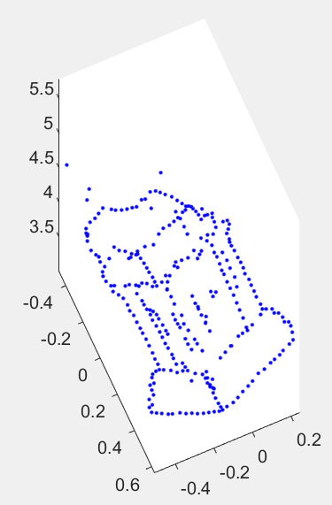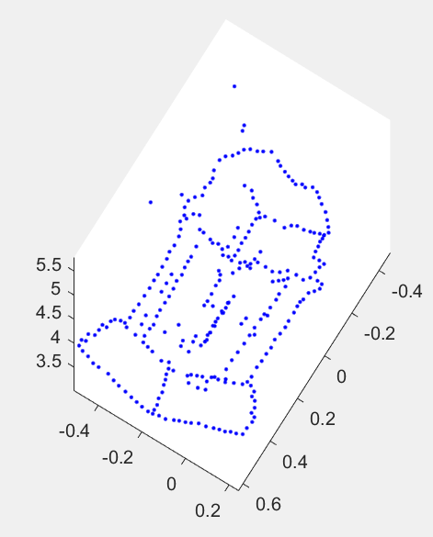3.1.5:

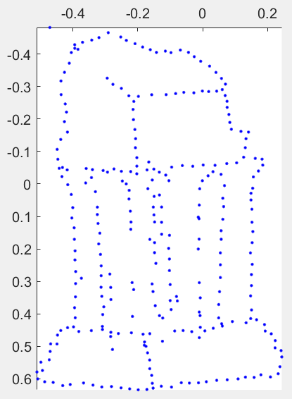

3.2.1:

3.2.2:

3.2.3:

3.3.1:

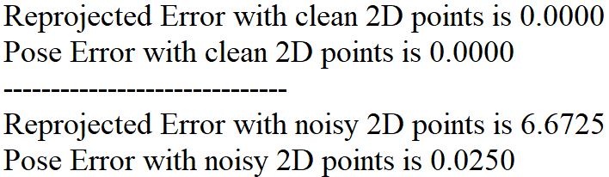

3.3.2:

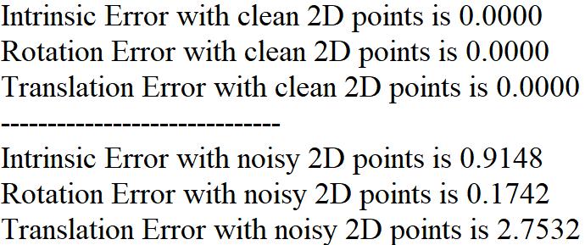

3.3.3:

  
